

**By**

**K. Deekshith Kiran Sai Teja**

EMPLOYEE MANAGEMENT SYSTEM

## Introduction:-

Everyorganization, whether big or small, has human resource challenges to overcome. every organization has different employee management needs, therefore we design exclusive employee manage mentsystemsthatareadaptedtoyourmanagerialrequirements.Thisisdesigned to assist in strategic planning, and will help you ensure that your organization is equipped with the right level of human resources for your future goals.

Also, for those busy executive who are always on the go, our systems come with remote access features, which will allow you to manage your workforce anytime, at all times.These systems will ultimately allow you to better manage resources. One of the main features in employee management system is time tracking for employees.Effectivetimetrackingmechanismsavesbothtimeandmoneyforthe

organization.

# PURPOSEOFTHESYSTEM:-

Asweknowinanytechnicaleducationaloffice,theman ager ofoffice used tospare lot oftime even after the normal office hours either

at home or office for preparation of daily/weekly report and other necessary record.Nowwiththehelpofthissystem,themanagerhastheinformationonhis finger tips and can easily prepare a record based on their requirements apart from daily/weekly report.Finally,We can say that this system will not only auto- mate the process but save the valuable time of the office manager, which can be well utilized by thisinstitute. This will be an additional advantage and manage- ment of manpower based on their free time from his normal duty.

# BENEFITSOFTHISSYSTEM:-

* + **Thissystemwiireducethecomplexcityofemployeemanagement.**
  + **Byusingthissystemwecaneasilymaintainalltherecordsabout”ON EMPLOYEES” or “OFF EMPLOYEES”.**
  + **Itwillreducesearchingtime.**
  + **It can be easily handeled by the person who have elementary know ledgeofcomputerbecauseitprovidesanuserfriendlyenvironment.**
  + **It’shardwareandsoftwareconfigurationisnotverycostlythatmeans**

Thehardwareandandsoftwarerequirementforthissoft ware/project are not very costly.

## WhatisVisualBasic?

The “Visual” part refers to the method used to create the graphical user interface (GUI). Rather than writing numerous lines of code todescribe the appearance and location of interface elements, you simply add pre-built objects into place on screen. If you’ve ever used adrawingprogramsuchasPaint,youalready have most of the skills necessary to create an effective user interface.

The“Basic”partreferstotheBASIC(BeginnersAll-Purpose Symbolic Instruction Code) language, a language used by more programmers than any other language in the history of computing. Visual Basic has evolved from the original BASIC language and now contains several hundreds statements, functions, and keywords. Many of which are related directly to the windows GUI.Beginners can create use ful application by learning just a few of the keywords, yet the language allows profess sionals to accomplish anything that can be accomplished using any other Windows pro gramming language.

TheVisualBasicProgramminglanguageisnotuniquetoVisualBasic.The Visual Basic programming system, Applications Edition includes in Microsoft Excel, Mi crosoft Access, and many other Windows application use the same language. The Visual Basic Scripting Edition (VBScript) is a widely used scripting language and a subseto f

theVisualBasiclanguage.TheinvestmentyoumakeinlearningVisualBasicwillcarry over to these other areas.Whether your goal is to create a small utility for yourself or your work group, a large enterprise-wide system, or even distributed applications spanning the globe via the internet, Visual Basic has tools you need.

* + **ctiveX technologies allow you to the functionality provided by other applications, such as Microsoft Word processor, Microsoft Excel spreadsheet and other windows applications. You can even automate applications and objects created using the Professional or enterprise of Visual Basic.**
  + **Internet capabilities make it easy to provide access to documents and application or to create Internet server applications.Your finished application is a true, .exe file that uses a Visual Virtual Machine that you can freely distribute.**

# VISUALBASICEDITIONS:-

Visual Basic is available inthreeversions,eachgearedtomeetaspecific set of development requirements.

* + **TheVisualBasicLearningeditionallowsprogrammerstoeasilycreate powerful**

applicationsforMicrosoftWindowsandWindows NT. It includes all intrinsic controls, plus grid, tab, data-bound controls.

* + **The professional’s edition provides computer professionals with afull-featured setoftoolsfordevelopingsolutionsforothers.Itincludesallthefeaturesofthe Learning edition,plusadditionsDesigner,IntegratedVisualDatabasesToolsand data Environment, Active Data Object and Dynamic HTML Pages Designer.**
  + **The Enterprise edition allows professionals to create robust distributed applications in a team setting. It includes all the features of the professional edition, plus back office tools such as SQL Server,MicrosoftTransactionServer, Internet Information System, Visual SourceSafe and more.**

# MS ACCESS

Microsoft Office Access, previously known as Microsoft Access, is a pseudo [relational database management system](http://system/) from [Microsoft](http://microsoft/) that combines the relational [Microsoft Jet Database Engine](http://engine/) with a [graphical user interface](http://interface/) and software development tools. It is a member of the [Microsoft Office](http://office/) suite of applications,includedintheProfessionalandhighereditionsorsoldseparately.

Microsoft specified the minimum hardware requirements for Access v2.0: Microsoft Windows v3.1 with 4 MB of [RAM](http://memory/) required, 6 MB RAM recommended; 8 MB of available [hard disk](http://disk/) space required, 14 MB hard disk space recommended. Users can create tables, queries, forms and reports, and connect them together with macros. Advanced users can use [VBA](http://applications/) to write rich solutions with advanced [data manipulation](http://manipulation/) and user control. FEASIBILITYSTUDY:-

Thefeasibilitystudyofthisprojecthasrevealedtheprojectasfollows:-

### ECONOMICFEASIBILITY

The project has shown the economic feasibility by the study of the fact that by using this software the increased number of the consumers can be given service effectively and efficientlyandcansavealottimeandsavingtimemeanssaving money. The costand benefit analysis has shown that costthathave incurredin developing the project is less than the benefits that the project is going to provideonce it is developed, so this project has passedthe feasibility test.

### BEHAVIOURALFEASIBILITY

### The working staff members are also interested in this project, as it will help them to do work with ease andefficientlywithoutcomplexity,sotheysupported the development of this project with full enthusiasm. This shows the behavioral feasibility of the project.

### TECHNICALFEASIBILITY

Technical feasibility centers ontheexistingcomputersystem(Hardware, Software etc) and to what extent it supports the existing system. As the existing system computer system is viable so there is no matter of technical feasibility that is the system is technically feasible.

### TIMEFEASIBILITY

It is the determination of whether a proposed project can be implemented fully withinstipulatedtimeframe.Theprojectwasdecidedtobedonein three months and was thought to be feasible enough.

# REQUIREMENTANALYSIS:-

The aim of requirement analysis istounderstandtheexactrequirement of the customer and to document and to document them properly.Requirement analysis involves obtaining a clear and thorough understanding of the product to be developing with a view to remove all ambiguities and inconsistencies from the initial customer perception the problem.

Thequestionarisingduringtherequirementanalysisphasesis:-

* + **Whatistheproblem?**
  + **Whyisitimportanttosolvethe problem?**
  + **Whatarethepossiblesolutionstotheproblem?**
  + **Whatexactlyarethedatainputsanddataoutputsby system?**
  + **Whatarethelikelythecomplexcitiesthatmightarisewhilesolvingthe problem?**

Duringrequirementanalysisthereexistmainlytwoactivities.

* + 1. **Requirementgathering**
    2. **Analysisofgatheredrequirements.**

Requirement gathering: -Thisinvolvesinterviewingtheenduserandcustomersto collect all possible information regarding the bank.

Analysis of gathered requirement: - The main purchase of analysis is to collect information to clearly understand the exact requirement of customer and resolve anomalies, conflicts and inconsistencies in the gathered requirement.

SOFTWARELIFECYCLEADOPTED:-

In order to develop the project “Employee Management” we haveadopted the iterative enhancement model. This model removes the shortcoming of waterfall model. Since many facts of this system are already known. It is not a new concept and hence no research is required. Aworkingversioncanbeeasilycreatedand hence the system can start working. Rest of the functionalities can be implemented in the next iteration and can be delivered later. As the requirement analysis is also not required. It not being a new technology risk involved is also less. So one need not perform detailed risk analysis. If redevelopment staff is less than development can be started with less number of people and in next increments others can be involved. As this model combines the advantage of waterfall model and prototyping, clients are always aware of the product being delivered and can always suggest changes and enhancements and can get them implemented

**RequirementAnalysis** C**oding**T**esting**

Ma**intenance** D**esign**

Deliveryoffirstincrement Thusincrementsaredevelopedtillfinalproductisnotobtained.

## FLOWDiagramoftheproposedsoftware.

**VIEW**

**DAILY ATTENTRYPAGE**

VIEW

DAILY ATTENDENCE EXIT

ENDENCE

### HOME PAGE

**ENTRYPAGE**

STORAGEi.e. DATABASE EXIT

## FLOWDiagramforentryinganewemployee:-

**NEWENTRYPAGE BACK SUBMIT**

**NEW**

**DATABASE**

* **NEWENTRYPAGE:-Inthispageweenteralltherecordsorinformationsabout a employee.**
* **SUBMIT:-Thisisusedtosavetherecordinthedatabase.**
* **BACK**:-**Thisisusedtocomebackfromnewentrypagei.e.intheHOMEPAGE.**
* **NEW:-ThisisusedtoblanktheentryformfieldsforenteringnewrecordsforNEXT employee.**

**VIEW**

## FLOWDiagramforviewingtherecords:-

**“OFF” EMPLOYEES “ON” EMPLOYEES**

**RECORDSOFALLWORKING RECORDSOF**

**ALLLEFT. EMPLOYEES**

**EMPLOYEES**

## FLOWDiagramforviewingtherecordsof“ON”employees:-

“on”employees records

Attendancedetails Salary details

Employee permanent details

**Searchfram**

**(forsearchingaboutaparticularemp.)**

## FLOWDiagramforviewingtherecordsof“OFF”employees:-

“**OFF”employees records**

Attendance details

Employee permanent details Search fram

(forsearchingaboutaparticularemp.Whohaslefttheorganization) Salary details

FLOWDiagramforentryingdailyattendance:-

New Back

Submit

**Attendancepage Attendance button**b

Home page

Database

**DATABASEDESIGN**

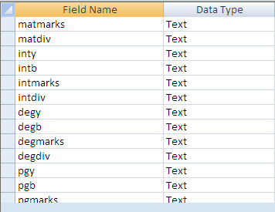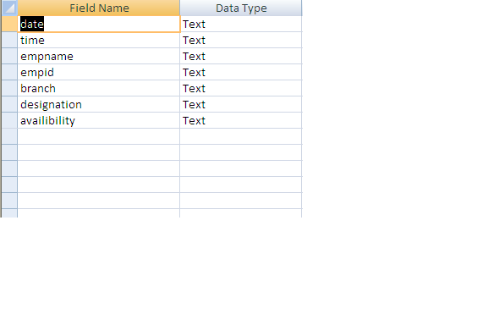

**Table1**

Attendencetable:-

ABOUTPAGESUSEDINTHEPROJECT:-

* + - **HOMEPAGE:-Itisthefrontpagewhereallthebuttonsarepresent,Theyare-**
      * **Recordentry**
      * **View**
      * **Daily attendance**
      * **Exit**
    - **SELECTIONPAGE:-Itisthepagewherewehavetoselect,Whomrecord we want to view ON emp record or OFF emp record.**
    - **RECORDPAGE:-Itisthepagewhererecordsofalltheemployeesare present.if it is ON employee record page it contains record about ON employees and if it is OFF employee page it contains record about OFF employees.**
    - **SEARCH FRAME:- It is the frame where we have to enter emp name and empidforgetmoreinformationaboutaparticularemployee.Afterentrying name and id, we can know-**
      * **Employeepermanentrecord**
      * **Employeesalary details**
      * **Employeeattendancerecord**
      * **DAILYATTENDENCEPAGE:-Itisthepagebywhichweenterdailyattendance of all working employees.**
      * **EMPLOYEEPERMANENTRECORDPAGE:-Itisthepagewhereallthe permanent records about an employee is present.such as- Emp name**

,Qualification,Experienceetc.

* + - * **EMPLOYEESALARYDETAILS:-Itisthepagewheresalarydetailsaboutan particular employee is present. Such as salary scale,Basic,H.R.A.,D.A etc.**
      * **EMPLOYEEATTENDENCERECORD:-Itisthepagewhereattendencerecord of a particular employee is present. Such as- no. of attendance in current month.**

# TESTING

This phase determine the error in the project. If there is any error then it must be removed before delivery of the project. For determining errors various types of test action are performed.

1. **UnitTesting:-**

Unit testing focuses verification effort on the smallest unitofsoftware design – the module. Using the detail design description as a guide, importantcontrol paths are tested to uncover errors within the boundary of the module. The relative complexity of tests and the errors detected as a result is limited by the constrained scope established for unit testing. The unit test is always white box oriented, and the step can be conducted in parallel for multiple modules.

1. **SystemTesting:-**

Software is only one element of a larger computer based system. Ultimately, software is incorporated with othersystemelements(e.g.newhardware, information), and a series of system integration and validation tests are conducted. Steps taken during software design and testing can greatly improve the probability of successful software integration in the larger system.

IntegrationTesting:-

The selection of an integration strategy depends upon software characteristic and,sometimeprojectschedule.Ingeneral,acombinedapproachthat uses the top-down strategy for the upper levels of the program structure, coupled with a bottom-up strategy for the subordinate levels, may be the best compromise.

# SNAPSHOTWITHCODE:-

**Form1:-**

PrivateSubCommand1_Click() Form2.Show

UnloadMe End Sub

PrivateSubPicture1_Click()

End Sub

PrivateSubCommand2_Click() Form4.Show

UnloadMe End Sub

PrivateSubCommand3_Click() Form3.Show

UnloadMe End Sub

PrivateSubCommand4_Click() Form1.Hide

End Sub

### FORM2:-

Dim empid As String PrivateSubImage1_Click() End Sub

Private Sub Combo2_Change()

Combo2.Text=Combo2.List(Combo2.ListIndex) End Sub

PrivateSubCommand1_Click() Form1.Show

UnloadMe End Sub

Private Sub Command2_Click()

Dim rs As New Recordset

rs.Open"insertintotable1values('"&Text1.Text&"',

'"&Text2.Text&"',

'"&Text3.Text&"',

'"&Text10.Text&"',

’"&Text4.Text&"',

'"&Text5.Text&"',

'"&Text31.Text&"',

'"&Combo4.Text&"',

'"&DTPicker2.Value&"', '"& Combo1.Text &"',

'"&Combo3.Text&"',

'"&Combo2.Text&"',

'"&Text7.Text&"',

'"&Text11.Text&"',

'"&Text15.Text&"',

'"&Text19.Text&"',

'"&Text23.Text&"',

'"&Text12.Text&"',

'"&Text16.Text&"',

'"&Text20.Text&"',

'"&Text24.Text&"',

'"&Text13.Text&"',

'"&Text17.Text&"',

'"&Text21.Text&"',

'"&Text25.Text&"',

'"&Text14.Text&"',

'"&Text18.Text&"',

'"&Text22.Text&"',

'"&Text26.Text&"',

'"&Text27.Text&"',

'"&Text20.Text&"',

'"&Text29.Text&"',

'"&Text30.Text&"')",con MsgBox("RecordSaved...") EmpCode

End Sub

PrivateSubCommand3_Click() Text1.Text = ""

Text3.Text = "" Text4.Text = "" Text10.Text = "" Text4.Text = "" Text5.Text = "" Combo1.Text="" Combo3.Text="" Combo2.Text="" Text11.Text = "" Text15.Text = ""

Text19.Text="" Text23.Text="" Text12.Text="" Text16.Text="" Text20.Text="" Text24.Text="" Text13.Text="" Text17.Text="" Text21.Text="" Text25.Text="" Text14.Text="" Text18.Text="" Text22.Text="" Text26.Text="" Text27.Text="" Text20.Text="" Text29.Text="" Text30.Text=""Text7.Text = ""Text31.Text="" Text28.Text=""End Sub

PrivateSubForm_Load() EmpCode

End Sub

Private Sub EmpCode()

Dim rsCode As New ADODB.Recordset

rsCode.Open"SelectCount(EmpID)asEmpidfromtable1",con,adOpenDynamic, adLockPessimistic, adCmdText

empid="KKP/"&rsCode(0)+1001 Text2.Text = empid

rsCode.Close End Sub

### FORM3:-

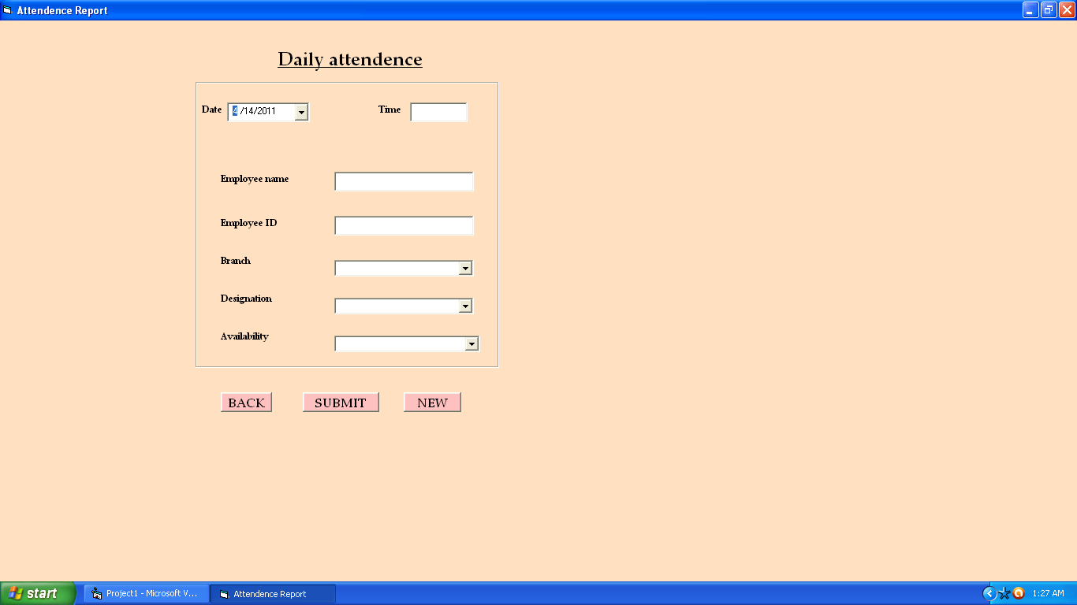

Private Sub Command1_Click()

Dim rs As New Recordset

rs.Open"insertintoattendencevalues('"&DTPicker1.Value&"', '"& Text1.Text &"',

'"&Text2.Text&"',

'"&Text3.Text&"',

'"&Combo2.Text&"',

'"&Combo3.Text&"',

'"&Combo1.Text&"')",con End Sub

PrivateSubCommand2_Click() Form1.Show

UnloadMe End Sub

PrivateSubCommand3_Click() Text1.Text = ""

Text2.Text = "" Combo3.Text="" Text3.Text = "" Combo2.Text="" Combo1.Text="" End Sub

PrivateSubForm_Load() End Sub

# FORM4:-

PrivateSubCommand1_Click()Form5.Show

UnloadMeEnd Sub

PrivateSubCommand3_Click()Form1.Show

UnloadMeEnd Sub

PrivateSubForm_Load()End Sub

### FORM5:-

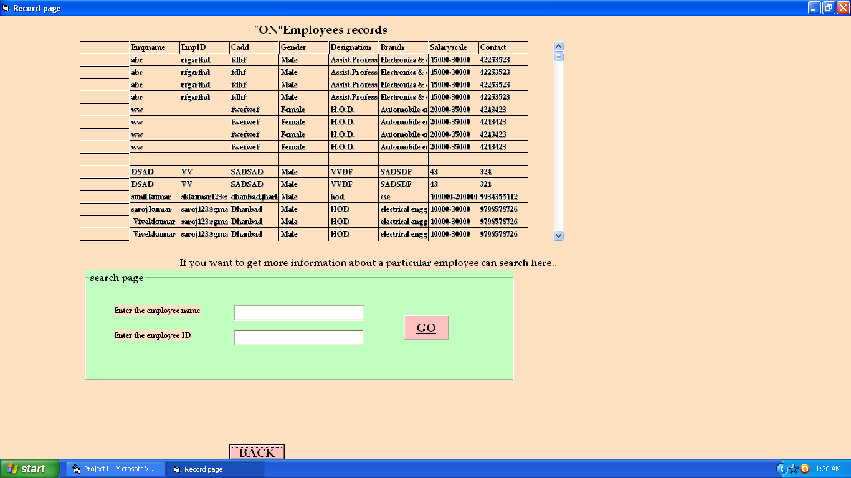

Private Sub Form_Load() fixMyData.Visible = True Frame3.Visible = False Command5.Visible=False Frame2.Visible = False Frame6.Visible = False

Set rs = New ADODB.Recordset rs.CursorLocation = adUseClient

rs.Open"selectEmpname,EmpID,Cadd,Gender,Designation,Branch,Salaryscale,Contact from table1", con, adOpenDynamic, adLockPessimistic, adCmdText

Set fixMyData.Recordset = rs

End Sub

PrivateSubmydatafixed_Click()End Sub

PrivateSubFrame2_DragDrop(SourceAsControl,xAsSingle,YAsSingle)rst As New Recordset

End Sub

PrivateSubFrame6_DragDrop(SourceAsControl,xAsSingle,YAsSingle)

Dim rs1 As New Recordsetrs1.Open"select*fromtable2",con

Do While Not rs1.EOFCombo2.AddItem(rs1!table2)rs1.MoveNext

End Sub

### SEARCHFRAME:-

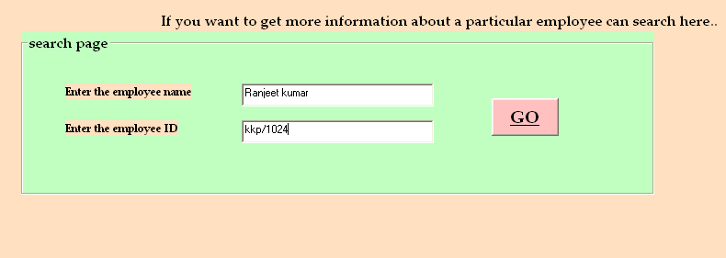

Private Sub Command2_Click()

If(Len(Trim(Text1.Text))>0)Then Frame2.Visible = True

Else

MsgBox("PleasinsertempIDandempname..") End If

End Sub

### PARTICULARSEARCHPAGES:-

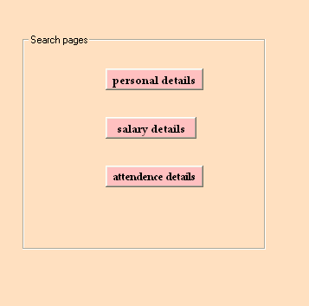

PrivateSubFrame2_DragDrop(SourceAsControl,XAsSingle,YAsSingle) rst As New Recordset

End Sub

### PERSONALDETAILSPAGE:-

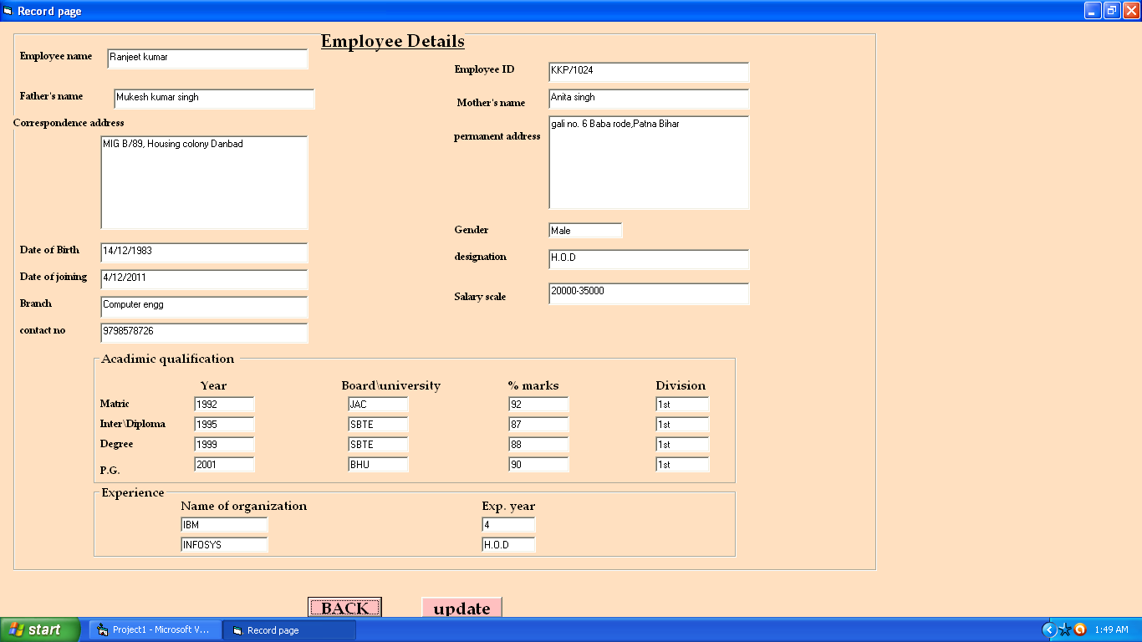

PrivateSubCommand1_Click() Form4.Show

UnloadMe End Sub

Private Sub Command2_Click()

If(Len(Trim(Text1.Text))>0)Then Frame2.Visible = True

Else

MsgBox("PleasinsertempIDandempname..") End If

End Sub

Private Sub Command5_Click()

Dim rs2 As New Recordset

rs2.Open"updatetable1setempname='"&Text3.Text&"', fname='"& Text5.Text &"',mname='"& Text11.Text &"'

,cadd='"&Text7.Text&"',padd='"&Text10.Text&"',dob='"&Text35.Text&"', doj='"& Text6.Text &"',branch='"& Text8.Text &"',

contact='"& Text12.Text &"',gender='"& Text9.Text &"', designation='"&Text32.Text&"',salaryscale='"&Text33.Text&"',

maty='"& Text13.Text &"',matb='"& Text17.Text &"', matmarks='"&Text21.Text&"',matdiv='"&Text25.Text&"', inty='"& Text14.Text &"',intb='"& Text18.Text &"', intmarks='"& Text22.Text &"',intdiv='"& Text26.Text &"', degy='"& Text15.Text &"',degb='"& Text19.Text &"', degmarks='"&Text23.Text&"',degdiv='"&Text27.Text&"', pgy='"& Text16.Text &"',pgb='"& Text20.Text &"', pgmarks='"& Text24.Text &"',pgdiv='"& Text28.Text &"', noorz1='"& Text29.Text &"',expyear1='"& Text30.Text &"', noorz2='"& Text31.Text &"',expyear2='"& Text32.Text &"'

whereempname='"&Text1.Text&"'andempid='"&Text2.Text&"'",con 'rs2.Open " update table1 set empname='"& Text3.Text &"',

fname='"&Text5.Text&"',mname='"&Text11.Text&"', cadd='"& Text7.Text &"',padd='"& Text10.Text &"'

whereempname='"&Text1.Text&"'andempid='"&Text2.Text&"'",con End Sub

PrivateSubCommand6_Click() Frame2.Visible = False Frame1.Visible = False Label1.Visible = False Label4.Visible = False Command5.Visible = True 'Labell.Visible = False 'Label4.Visible = False fixMyData.Visible = False Frame1.Visible = False Frame3.Visible = True

'rst As New Recordset DimrstAsNewRecordset

rst.Open"select*fromtable1whereempname='"&Text1.Text&"' and empid='"& Text2.Text &"'", con

Text3.Text=rst!empname Text4.Text = rst!empid Text5.Text = rst!fname Text11.Text = rst!mname Text7.Text = rst!cadd Text10.Text = rst!padd

Text35.Text = rst!dob Text6.Text = rst!doj Text8.Text = rst!branch Text12.Text = rst!contact Text9.Text = rst!gender Text32.Text=rst!designation Text33.Text=rst!salaryscale Text13.Text = rst!maty

Text17.Text = rst!matb Text21.Text=rst!matmarks Text25.Text = rst!matdiv Text14.Text = rst!inty Text18.Text = rst!intb Text22.Text = rst!intmarks Text26.Text = rst!intdiv Text15.Text = rst!degy Text19.Text = rst!degb Text23.Text=rst!degmarks Text27.Text = rst!degdiv Text16.Text = rst!pgy Text20.Text = rst!pgb Text24.Text = rst!pgmarks Text28.Text = rst!pgdiv Text29.Text = rst!noorz1 Text30.Text = rst!expyear1 Text31.Text = rst!noorz2 Text34.Text = rst!expyear2 End Sub

PrivateSubCommand7_Click() Frame6.Visible = True fixMyData.Visible = False Frame2.Visible = False Frame1.Visible = False Label1.Visible = False Label4.Visible = False Frame3.Visible = False Frame2.Visible = False

Dim rsp As New Recordset

rsp.Open"select*fromtable1whereempname='"&Text1.Text&"' and empid='"& Text2.Text &"'", con

Text44.Text=rsp!salaryscale End Sub

Private Sub Form_Load() fixMyData.Visible = True Frame3.Visible = False Command5.Visible=False

Frame2.Visible=False Frame6.Visible=False

Set rs = New ADODB.Recordset rs.CursorLocation = adUseClient

rs.Open"selectEmpname,EmpID,Cadd,Gender,Designation,Branch,Salaryscale, Contact from table1", con, adOpenDynamic, adLockPessimistic, adCmdText

Set fixMyData.Recordset = rs

End Sub

PrivateSubmydatafixed_Click() End Sub

PrivateSubFrame2_DragDrop(SourceAsControl,xAsSingle,YAsSingle) rst As New Recordset

End Sub

PrivateSubFrame6_DragDrop(SourceAsControl,xAsSingle,YAsSingle)

Dim rs1 As New Recordset

rs1.Open"select*fromtable2", con

Do While Not rs1.EOF Combo2.AddItem(rs1!table2) rs1.MoveNext

End Sub

### SALARYPAGE:-

PrivateSubFrame6_DragDrop(SourceAsControl,xAsSingle,YAsSingle)

Dim rs1 As New Recordset

rs1.Open"select*fromtable2", con

Do While Not rs1.EOF Combo2.AddItem(rs1!table2) rs1.MoveNext

End Sub

CONCLUSION:-

This software/package is designed especially for the officeandcanbereplicatedwithminormodificationinanytechnicaleducational organization office.The database of this system can also easily be ported in any other standard database with nominal change. The manager ofoffice used to spare lot oftime even after the normal office hours either at home or office for

preparationofdaily/weeklyreportandothernecessaryrecord.